
TRIBHUVAN UNIVERSITY
Faculty of Humanities and Social Sciences

Dog Adoption System
A Project Report
Submitted to
Department of Computer Application
JANAMAITRI MULTIPLE CAMPUS
In partial fulfillment of the requirements for the Bachelors in Computer Application
Submitted by
Manoj Pathak
TU Reg. No:6-2-263-30-2022
Ruby Chaudhary
TU Reg. No: 6-2-263-36-2022

Under the Supervision of
Kamal Tamrakar
Tribhuvan University
Faculty of Humanities and Social Sciences
Janamaitri Multiple Campus (JMC)

Supervisor’s Recommendation

I hereby recommend that this project has been prepared under my supervision by Manoj Pathak (Redg No: 6-2-263-30-2022) and Ruby Chaudary (Redg No: 6-2-263-36-2022) entitled "AdoPups" (A dog adoption platform) in partial fulfillment of the requirements for the Bachelor's degree of BCA (Bachelor of Computer Application) is recommended for the final evaluation.

SIGNATURE
Kamal Tamrakar

____________
SUPERVISOR
Janamaitri Multiple Campus (JMC)
Kuleshwar Kathmandu


Tribhuvan University
Faculty of Humanities and Social Sciences
Janamaitri Multiple Campus
LETTER OF APPROVAL
I hereby recommend that this project has been prepared under my supervision by Manoj Pathak (Redg No: 6-2-263-30-2022) and Ruby Chaudary (Redg No: 6-2-263-36-2022) entitled "AdoPups" (A dog adoption platform) in partial fulfillment of the requirements for the Bachelor's degree of BCA (Bachelor of Computer Application) is recommended for the final evaluation.
Signature of Supervisor  ……………………………..  Kamal Tamrakar  (Supervisor) | Signature of HOD/ Coordinator  ………………………………  Kamal Tamrakar  (HOD/Coordinator)
Signature of Internal Examiner  ………………………………..  Internal Examiner | Signature of External Examiner  ………………………………..  External Examiner

ABSTRACT
The Dog Adoption System is a web-based platform designed to facilitate the adoption of dogs and allow users to donate funds for their welfare. The system streamlines the adoption process by requiring adopters to register, submit adoption requests, and receive admin approval before proceeding with the adoption. It also includes a donation module where users can contribute financially. The system is built using HTML, CSS, JavaScript, and PHP, with a MySQL database for storing user, dog, adoption, and donation records.
The project aims to address the challenges faced by dog shelters in Nepal, where many stray and abandoned dogs require proper care and a loving home. By digitizing the adoption and donation process, the system ensures transparency, efficiency, and ease of access for both adopters and administrators.
Keywords: Dog Adoption, Web-based System, PHP, MySQL, Online Donations

ACKNOWLEDGEMENT
We extend our sincere gratitude to all those who contributed to the development of this project. First and foremost, we express our heartfelt thanks to the Department of Bachelors of Computer Applications for their indispensable support and resources, without which this project would not have been possible. We also acknowledge the invaluable guidance and mentorship provided by Mr. Kamal Tamrakar throughout the duration of this project. His expertise and insights have been instrumental in shaping our approach and achieving our objectives. Additionally, we appreciate the collaboration, dedication, and hard work of each team member. Our combined efforts have been crucial in bringing this project to fruition.

Furthermore, the authors would like to express their sincere gratitude to Kamal Tamrakar, Head of Department at Janamaitri Multiple Campus, for his unwavering support, guidance, and valuable insights during the conceptualization of this project. His leadership and encouragement were instrumental in shaping the direction of our work.

Special thanks are extended to Abita Kunwar Madam for her expertise and assistance in database management and entity-relationship modeling, significantly enhancing the technical aspects of our project.

This work would not have been possible without the collaborative efforts and support of these individuals. Their contributions have played a pivotal role in the successful formulation of this proposal and will undoubtedly impact the success of the subsequent project

TABLE OF CONTENTS
ABSTRACT iii
ACKNOWLEDGEMENT iv
LIST OF ABBREVIATIONS vii
LIST OF FIGURES viii
LIST OF TABLES ix
CHAPTER 1: INTRODUCTION 1
1.1 Introduction 1
1.2 Problem Statement 1
1.3 Objectives 1
1.4 Scope and Limitations 1
1.4.1 Scope 2
1.4.2 Limitations 2
1.5 Report Organization 2
CHAPTER 2: BACKGROUND AND LITERATURE REVIEW 4
2.1 Background Study 4
2.2 Literature Review 5
CHAPTER 3: SYSTEM ANALYSIS AND DESIGN 8
3.1 System Analysis 8
3.1.1 Methodology 8
3.1.2 Requirement Analysis 8
3.1.3 Feasibility Study 10
3.1.4 Data Modelling (ER-Diagram) 11
3.2 System Design 14
3.2.1 Architectural Design 14
3.2.2 Database Schema Design 15
CHAPTER 4: IMPLEMENTATION AND TESTING 18
4.1 Implementation 18
4.1.1 Tools Used (CASE tools, Programming language, Database platforms) 18
4.1.2 Implementation Details of Modules (Description of procedures/functions) 20
4.2 Testing 21
4.2.1 Test Cases for Unit Testing 21
CHAPTER 5: CONCLUSION AND FUTURE RECOMMENDATIONS 33
5.1 Lesson Learnt / Outcome 33
5.2 Conclusion 34
5.3 Future Recommendations 34
References 35
Appendices Error! Bookmark not defined.

LIST OF ABBREVIATIONS
CRUD: Create, Read, Update and Delete
CSS: Cascading Style Sheet
DFD: Data Flow Diagram
ERD: Entity Relationship Diagram
HTML: Hyper Text Markup Language
DAS: Dog Adoption System
JS: JavaScript
MySQL: My Structured Query Language
PHP: Hypertext Preprocessor
SMEs: Small and Medium Size Enterprises

LIST OF FIGURES
Figure 3.1 Waterfall Model 8
Figure 3.2 Use Case Diagram of Dog Adoption System 8
Figure 3.3 Gantt Chart for Dog Adoption System 11
Figure 3.4 ER Diagram of Dog Adoption System 12
Figure 3.5 Level 0 DFD for Dog Adoption System 13
Figure 3.6 Level 2 DFD for Dog Adoption System 13
Figure 3.7 Architectural Design of Dog Adoption System 14
Figure 3.8 Database Schema Design of Dog Adoption System 15
Figure 3.9 UI Home page of Dog Adoption System 16
Figure 3.10 Animal page for Dog Adoption System 16
Figure 3.11 Signup page for Dog Adoption System 20
Figure 3.14 Dashboard for Dog Adoption System 20

LIST OF TABLES
Table 3.1 Gantt Chart Table for Dog Adoption System 10
Table 4.1 Test Case for User registration of Dog Adoption System Error! Bookmark not defined.
Table 4.2 Test case for User Login of Dog Adoption System Error! Bookmark not defined.
Table 4.3 Test Case for Admin Login of Dog Adoption System 27
Table 4.4 Test Case for Adding and listing Categories of Dog Adoption System 27
Table 4.5 Test Case for Adding Dogs of Dog Adoption System 28
Table 4.6 Test Case for Adopting Dogs of Dog Adoption System 29

CHAPTER 1: INTRODUCTION

Introduction
Dog Adoption System (DAS) plays a crucial role in addressing issues related to stray and abandoned animals. Traditional methods of adoption often involve manual paperwork, inefficient tracking, and a lack of transparency in the approval process. Many organizations and individuals are adopting technology-driven solutions to streamline the adoption process, making it faster, more efficient, and more accessible via web-based platforms.
The Dog Adoption System is a web-based application developed using HTML, CSS, JavaScript, and PHP, aimed at automating the adoption request process, donation tracking, and management of dogs available for adoption. The system ensures a smooth experience for adopters and administrators, allowing users to submit adoption requests and donations, while admins review applications, manage dogs, and oversee donations.

Problem Statement
The existing process of dog adoption in Nepal is inefficient, and this system will address these challenges effectively:
- Lack of Centralized Adoption Records
  - Problem: Shelters rely on physical records, leading to data loss and mismanagement.
  - Solution: The system will introduce a centralized digital database for secure and efficient record-keeping.
- Limited Accessibility
  - Problem: Potential adopters face difficulties visiting shelters in person.
  - Solution: An online platform will enable users to browse, adopt, and donate from anywhere, enhancing accessibility.
- Manual Verification Process
  - Problem: The existing adoption process is slow due to extensive manual verification.
  - Solution: Automation will simplify and expedite the verification process for both adopters and administrators.

- Limited Funding Transparency
  - Problem: Donations are untracked, raising accountability concerns.
  - Solution: The system will provide a transparent donation tracking feature, ensuring accountability and trust.
This comprehensive solution will revolutionize the adoption and donation process, making it efficient, transparent, and user-friendly.

Objectives
The system provides solutions to contemporary issues encountered by DAS. Some of the objectives of this system are as follows: The primary objectives of this system are:
- To create an efficient online platform for dog adoption.
- To automate the adoption request and approval process.
- To provide a donation module for financial support to dog shelters.
- To enable administrators to manage adoptions, donations, and user data seamlessly.

Scope and Limitations
Every system has its strengths and areas for improvement. The DAS is designed to simplify the adoption and donation process, offering various features while acknowledging a few limitations.

Scope
The Dog Adoption System offers the following features:
- Users can register, log in, and submit adoption requests.
- Admins can review and approve/reject adoption requests.
- Users can donate money through an integrated donation form.
- Admins can manage user profiles, donations, and dog listings.

Limitations
Despite its capabilities, the system has the following limitations:
- No real-time chat between adopters and admins.
- Strong and secure payment gateway integration for donations is not yet implemented.
- Limited automation in adoption request approvals (admin review required).

Report Organization
Introduction
This chapter introduces the Dog Adoption System, providing an overview of the project's objectives, scope, and limitations. It also discusses the rationale behind the development of the system and the significance of its creation.
Background Study and Literature Review
In this chapter, previous research and work related to dog adoption systems are explored. It highlights the features and functionalities of existing applications and websites in the domain of animal adoption, providing a contextual background for the development of this system.
Requirement Analysis and System Design
This chapter focuses on analyzing the requirements for the Dog Adoption System. It covers:
- Functional Requirements: Describes the core functionalities that the system must perform.
- Non-Functional Requirements: Discusses performance, security, and usability considerations.
- Feasibility Analysis: Evaluates the technical, operational, and financial feasibility of the project.
- Entity-Relationship Diagram (ERD): Provides a visual representation of the system's data structure.
- Data Flow Diagram (DFD): Illustrates how data moves through the system.
- System Architecture Design: Describes the overall architecture of the website.
- Database Schema: Presents the structure and design of the database.
- Interface Design: Details the user interface design of the system, focusing on usability and accessibility.
Implementation and Testing
This chapter describes the tools, technologies, and methodologies used during the development of the Dog Adoption System. It includes:
- Development Tools: Overview of the software and tools used in the implementation.
- Implementation Details: Description of how the system was built and configured.
- Testing: Discusses the types of testing performed, the results obtained, and any issues identified and resolved during the testing phase.
Conclusion
This chapter summarizes the lessons learned throughout the development process. It highlights the outcomes of the project, the objectives achieved, and the functionality delivered. Additionally, it discusses potential areas for future improvements and enhancements to the system.

CHAPTER 2:
BACKGROUND AND LITERATURE REVIEW

2.1 Background Study
Nepal has been facing a growing problem of stray and abandoned dogs, posing significant challenges for animal welfare organizations and communities. Many dogs are left without proper food, shelter, and healthcare, leading to increased cases of malnutrition and diseases. Although various NGOs and animal shelters, such as KAT Centre and Sneha’s Care, are actively involved in rescue operations, the current dog adoption process remains inefficient, relying on manual paperwork and in-person visits [1]. This fragmented approach, combined with the lack of a centralized digital system, often leads to delays in adoption approvals and poor donation management.
Moreover, financial donations, essential for supporting rescue operations and medical care, are usually untracked and lack transparency, discouraging potential donors. Therefore, a structured, secure, and web-based Dog Adoption System is essential to streamline adoptions and manage donations effectively. The proposed system aims to offer a user-friendly, automated platform built with modern web technologies (HTML, CSS, JavaScript, PHP, and MySQL) to address these challenges efficiently [2].

2.2 Literature Review
2.2.1 Overview of Existing Online Pet Adoption Platforms
Several international online pet adoption platforms have demonstrated the importance of technology in streamlining pet adoptions. Notable examples include Petfinder, Adopt-a-Pet, and The Blue Cross, each with its unique set of features and limitations.
(a) Petfinder
Petfinder is one of the largest pet adoption platforms globally, connecting adopters with thousands of shelters and rescue groups [3].
Pros:
Extensive network of shelters, making numerous dogs available for adoption.
Advanced filtering options based on breed, age, and location.
Detailed pet profiles including photos and medical history.
Cons:
- No integrated donation management, requiring separate platforms for financial support.
- Manual processing of adoption requests, causing delays.
- Limited direct communication between adopters and shelters within the system[4].
(b) Adopt-a-Pet
Adopt-a-Pet is another leading platform helping adopters find pets from rescue organizations [5].
Pros:
- User-friendly interface with advanced search tools.
- Regularly updated listings from verified shelters.
- Educational resources for first-time adopters.
Cons:
- Lacks real-time tracking of adoption request status.
- No integrated system for donation tracking.
- Manual approval that can be time-consuming [6].
(c) The Blue Cross (UK)
The Blue Cross is a UK-based charity that also offers pet adoption through its online portal [7].
Pros:
- Integrated donation system supporting shelter operations.
- Detailed pet information including care needs and behavior.
- Educational content on animal welfare.
Cons:
- Limited to UK regions, not available globally.
- Manual review of adoption forms, leading to processing delays.
- No automated communication for updates on adoption status [8].
2.2.2 Current Pet Adoption Practices in Nepal
Unlike the structured international platforms, Nepal's pet adoption system is largely manual and uncoordinated. Shelters such as Sneha’s Care, Animal Nepal, and KAT Centre handle adoptions through physical visits, paper forms, and social media posts.
Pros of Existing Nepali System:
- Personalized adopter evaluation through face-to-face interactions.
- Direct involvement in pet selection and preliminary assessment.
Cons of Existing Nepali System:
- Manual paperwork causes delays and data loss.
- No centralized database for tracking adoption requests.
- Lack of transparency in donations, discouraging donors.
- Dependence on social media for communication, which lacks formal tracking.
- No notification system for application updates or donor acknowledgments [9].
2.2.3 Analysis of Gaps and Necessity for Digital Transformation
Although platforms like Petfinder and Adopt-a-Pet have streamlined parts of the adoption process, they lack integrated donation management and real-time adoption tracking. Additionally, they are region-specific and do not address Nepal's unique adoption ecosystem.
Nepal urgently needs a digital system that integrates adoption and donation processes, ensures secure user authentication, and automates approval workflows. According to a study by ASPCA, adoption rates can improve by 30-50% with proper online systems [10]. Furthermore, studies in Human-Computer Interaction (HCI) emphasize that intuitive and responsive interfaces can increase user engagement and reduce abandonment of adoption applications [11].
Security and transparency are also critical. Research indicates that donor trust depends on how transparent and accountable the donation system is [12]. Hence, implementing automated donation tracking and acknowledgment systems will improve financial management and donor confidence.

2.2.4 Technological Foundation of Proposed System
The proposed Dog Adoption System will leverage HTML and CSS for front-end design, JavaScript for interactivity, and PHP with MySQL for backend processing and data storage. Secure authentication, role-based access control, and encrypted data transactions will protect sensitive data and ensure that only authorized personnel manage the system [13].
2.3 Conclusion
The review of existing systems demonstrates that while international platforms like Petfinder, Adopt-a-Pet, and The Blue Cross provide basic online pet adoption features, they lack structured donation integration, automated workflows, and region-specific customization, which are critical for Nepal. In contrast, Nepal’s current system is completely manual and inefficient, with serious limitations in tracking, transparency, and user management.
Thus, the proposed Dog Adoption System will bridge these gaps by offering a fully automated, secure, and transparent platform, improving both adoption processes and financial management for shelters. This system will facilitate higher adoption rates, encourage responsible pet ownership, and ensure efficient utilization of donations, significantly contributing to animal welfare efforts in Nepal.

CHAPTER 3: SYSTEM ANALYSIS AND DESIGN

3.1 System Analysis
This system is designed with the series of processes starting with requirement analysis, design, implementation, testing and maintenance. During requirement analysis, all the functional and non-functional requirement are analyzed and system is developed according to the requirement are analyzed and system is developed according to the requirement then designing of the system is carried out. After the design process, coding and development part is started then after integrating the system there is testing of the system. If the testing is positive then the system is implemented otherwise some maintenance is done and system come in operation.

3.1.1 Methodology
The Waterfall model is ideal for DAS development because it takes a linear and sequential approach that is ideally suited to a project with clearly defined requirements. The Waterfall approach provides an organized methodology since the DAS must be strong and reliable, with each stage of development (requirements analysis, system design, implementation, testing, deployment, and maintenance) being completed before the next. This strategy ensures that any errors are identified early in the process, lowering the possibility of costly changes later. Furthermore, the Waterfall model's emphasis on extensive documentation at each stage facilitates straightforward communication of requirements and progress, which is vital for a project like DAS where correctness and completeness are paramount.
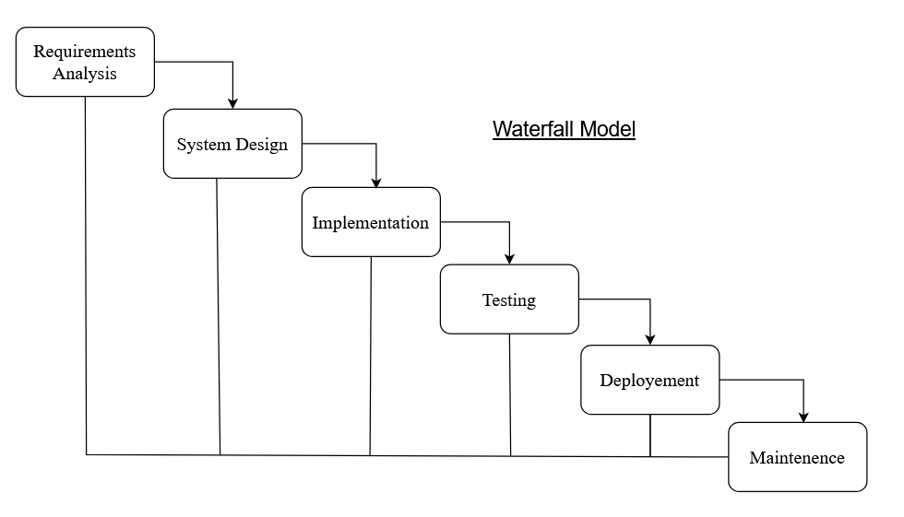
Figure 3.1 Waterfall Model

3.1.2 Requirement Analysis
The system's requirements are divided into two main categories: Functional Requirements and Non-Functional Requirements. Below is the detailed analysis for the functional requirements.

Functional Requirements
This section outlines the core functionalities that the system must provide to meet the needs of adopters, donors, and administrators.
For Adopter:
This section describes the functionalities required for the adopter's interaction with the system.
- Dog Adoption Process: The system must allow any individual (adopter) to adopt a dog, ensuring the adoption process is straightforward.
- Dog Preferences: The system must enable adopters to specify the type or breed of dog they wish to adopt.
- Adopter Registration: The system should allow adopters to register their valid personal information for future use, ensuring a smooth adoption process in subsequent sessions.
- Account Management: The system must facilitate the creation, modification, and management of adopter usernames and passwords to ensure secure access.

For Donation:
This section outlines the donation-related functionalities needed for the system.
- Donor Information: The system should maintain records of all donor information, including personal and payment details for transparency and tracking.
- Donation and Sponsorship: The system must enable donors to provide financial support through donations and sponsorships to assist with dog adoption costs and other needs.

For Administrator:
This section describes the administrative functionalities required for managing users and donations.
- Administrator Access: The system must allow the system administrator to securely log in and log out of the system to manage backend operations.
- User Management: The system must enable administrators to manage user data (both adopters and donors) as needed to maintain system integrity and security.
- User Data Monitoring: The system should allow administrators to monitor and manage all user data (adopters and donors), ensuring compliance and proper handling of information.
- Donation Oversight: The system should provide administrators with the ability to oversee and manage donations, including tracking financial contributions and donor activity.

Use Case Diagram 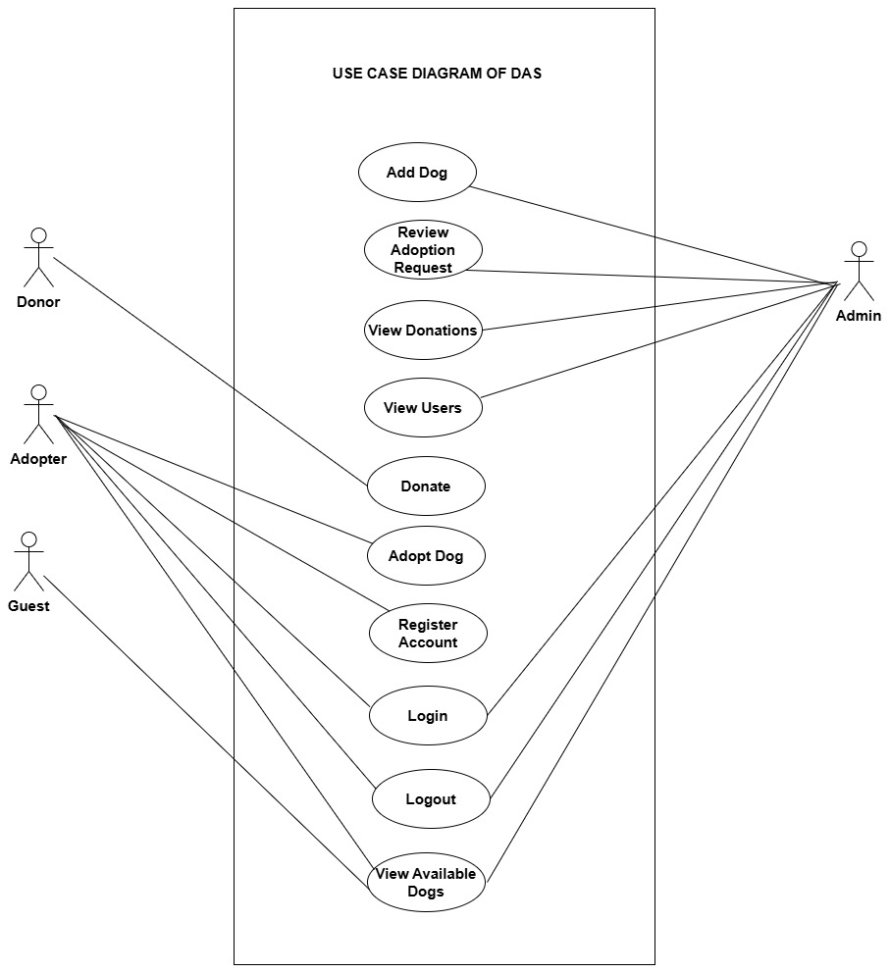
Figure 3.2 Use Case Diagram of Dog Adoption System

Non-functional Requirements
Different non-functional requirement have been studied and identified and are listed as below:
- Performance:- The performance of the system is fast and accurate as it provide fast response to the user’s actions. The system handle expected and unexpected errors and also large amount of data.
- Usability:-This system provides help and support menu in all interface for user to interact with the system. The user can use the system by reading and support.
- Security:- The system provides username and password during login to prevent any unauthorized access. This helps to provide security and privacy to both service provider and client.
- Availability:- The system is available for access at 24 hours and 7 days a week. Also, in the occurrence of any malfunctioning, the admin should notify the user and minimum 1-2 working days so that the business is not severely affected.

3.1.3 Feasibility Study

Technical Feasibility
We have conducted an initial analysis on our ongoing system. All the technical resources like programming languages, case tools, browser development tools and other essential materials are gathered to develop our system. We have listed all the critical elements like the target market, the expected goals and outcomes.

Operational Feasibility

Economic Feasibility
This system is economical to build. Since, only cost free technical resources are used, it have almost no financial expenses. But as our system is built for commercial purpose, we acquire financial benefits because our system take a few percent service charge from both the companies and applicants.

Schedule Feasibility
The system which we are going to develop will be completed within the scheduled time and will not exceed the scheduled time.
Table 3.1 Gantt Chart Table for Dog Adoption System
ID | Task Name | Start | Finish | Duration | Status
1 | Planning | 8/9/2024 | 8/23/2024 | 5 days | Completed
2 | Analysis | 8/26/2024 | 9/6/2024 | 20 days | Completed
3 | System Design | 9/9/2024 | 10/8/2024 | 32 days | Completed
4 | Development | 10/9/2024 | 2/3/2024 | 39 days | Completed
5 | Testing | 2/4/2024 | 2/20/2025 | 6days | Completed
6 | Documentation | 8/8/2024 | 2/20/2025 | 141 days | Completed

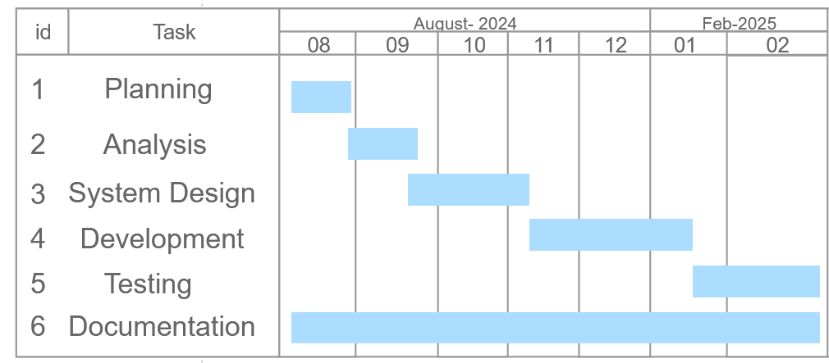
Figure 3.3 Gantt Chart for Dog Adoption System
The Gantt chart displays the project timeline for developing a "Dog Adoption System" spanning from July 2024 to March 2025. It includes seven tasks with their IDs and durations: Dog Adoption System (ID: 1) as the overarching project from July 2024 to March 2025; Planning (ID: 2) from July 2024 to August 2024; Analysis (ID: 3) from August 2024 to September 2024; System Design and Architecture (ID: 4) from September 2024 to October 2024; Development (ID: 5) from October 2024 to January 2025; Testing (ID: 6) from January 2025 to February 2025; and Documentation (ID: 7) from February 2025 to March 2025. The chart uses a vertical task list and a horizontal time axis marked in monthly increments (July 2024 to March 2025), with bars representing each task’s start, end, and duration, indicating a sequential workflow where tasks follow one another without overlapping, facilitating progress tracking and resource management for the software development project.

3.1.4 Data Modelling (ER-Diagram)
In Entity-Relationship diagram there are four entities named user, dogs, items, and admin. User has attributes like user id, name, password, email. Likewise, dogs has dogs id, breed, size, gender and items has attributes like items id, name, types and weightage. Admin has attributes like admin-id, password, name, email.

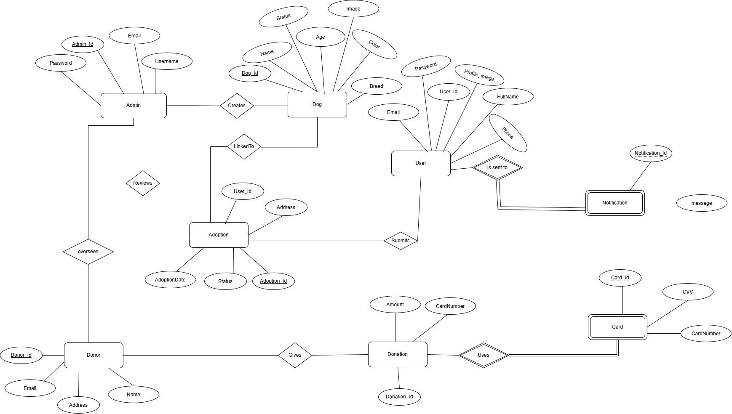
Figure 3.4 ER Diagram of Dog Adoption System
3.1.5 Process Modelling (DFD)
The Data Flow Diagram of Dog Adoption System consists of two levels of DFD context diagram and level two DFD. Both these levels are used for making data flow diagram of Dog Adoption System.
In context diagram, the login request, register, pets information are the inputs of Dog Adoption System where users and admin request for login, users register, users enquiry about pets for adoption. The login response, details of pets and adoption of pet are the outputs where admin and user get response about login success or cancel, admin get details of users and users get notification of pet information.
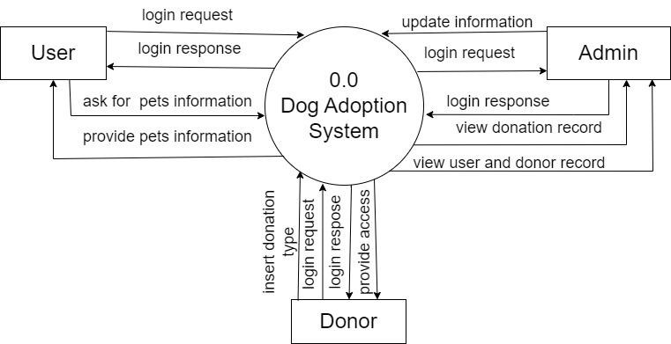
Figure 3.5 Level 0 DFD for Dog Adoption System
In level 2 DFD, there are five processes for login. Process 1 is responsible for managing category of dogs, process 2 is responsible likewise 3, 4, 5 are post adoptor managing details of dogs, and for adopting dogs. There are three entities admin, user, and doner and three data stores are used in this level of DFD such as user details ,dog category details and dog details.
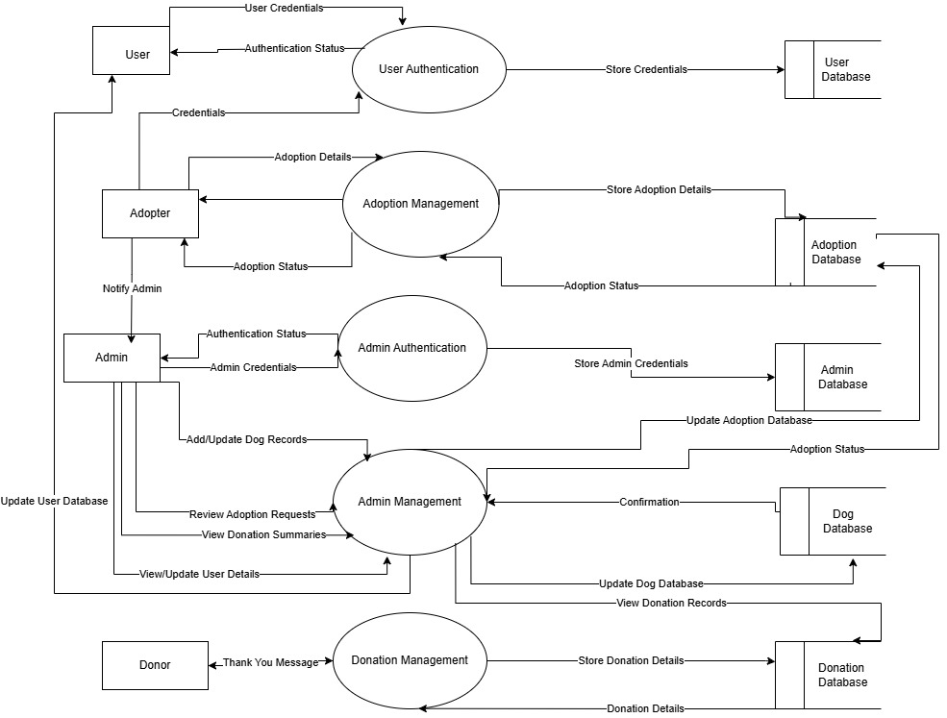
Figure 3.6 Level 2 DFD for Dog Adoption System

3.2 System Design
The system design of Dog Adoption System consists of architectural design, database schema design, user interface design and physical DFD are shown as follows:

3.2.1 Architectural Design
The architectural design of Dog Adoption System is based on Client-Server model where Apache server helps in server-side activities and user computer is used for client-side activities. Under client-server model, this system follows three-tier client server architecture.
- Client layer: It is also called as Presentation layer which contains user interface part of application. This layer communicates with other through Application Program Interface calls.
- Application layer: In this layer all business logic written like validation of data, calculations, data insertion etc. This acts as an interface between user tier and database tier for faster communication.
- Database layer: In this layer actual database is comes in the picture. Database Layer helps to connect with database and to perform insert, update, delete, get data from database based on user input data. These data are kept independent of application layer.
Following are the reasons behind choosing three tier-architecture:
- It makes the logical separation among three different layers.
- It makes the maintenance process easier.
- It makes us easier to update one tier without involving other.

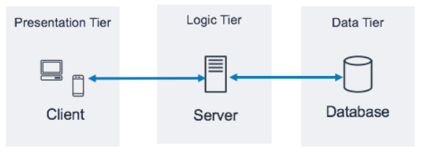
Figure 3.7 Architectural Design of Dog Adoption System

3.2.2 Database Schema Design
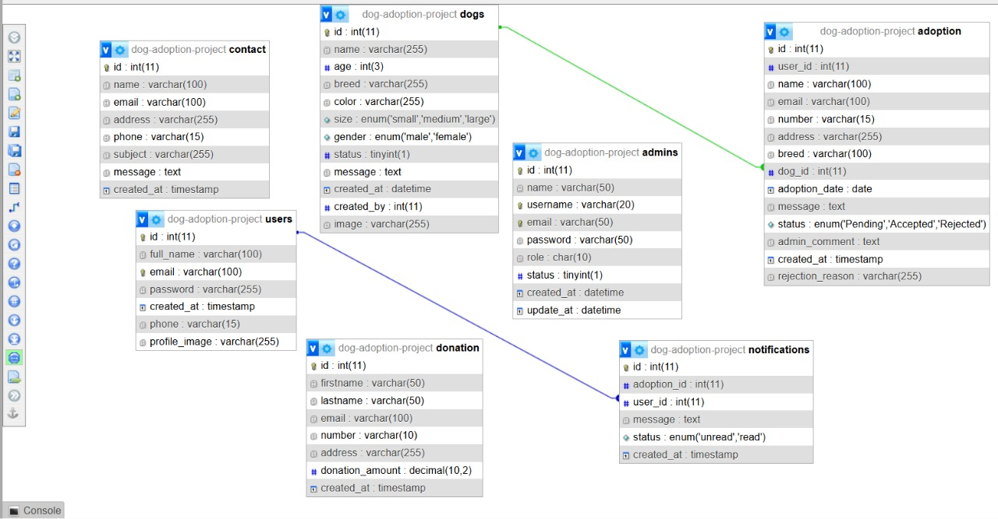
Figure 3.8 Database Schema Design of Dog Adoption System
The figure above is the database schema design of an Dog Adoption System. The database schema design for the Dog Adoption System involves defining the structure of the database, including the tables, fields, and relationship between them. The schema ensures that all necessary data is stored efficiently and can be retrieved and manipulated as needed.
3.2.4 Interface Design
The user interface design focuses on simplicity and usability, ensuring that users can easily navigate and perform necessary actions. The primary interfaces include:
- Registration and Login Page: Users can register and login to their account.
- Dashboard: Users can view and manage their adoption and donation request.
- Request Creation page: sellers/admin can add and create new dogs.
- Request viewing Page: Buyers can view available dog adoption request.
- Admin dashboard: Admins can manage user profiles, request and cancel.
The interface design was implemented using PHP, CSS, JavaScript to provide a dynamic and responsive user experience

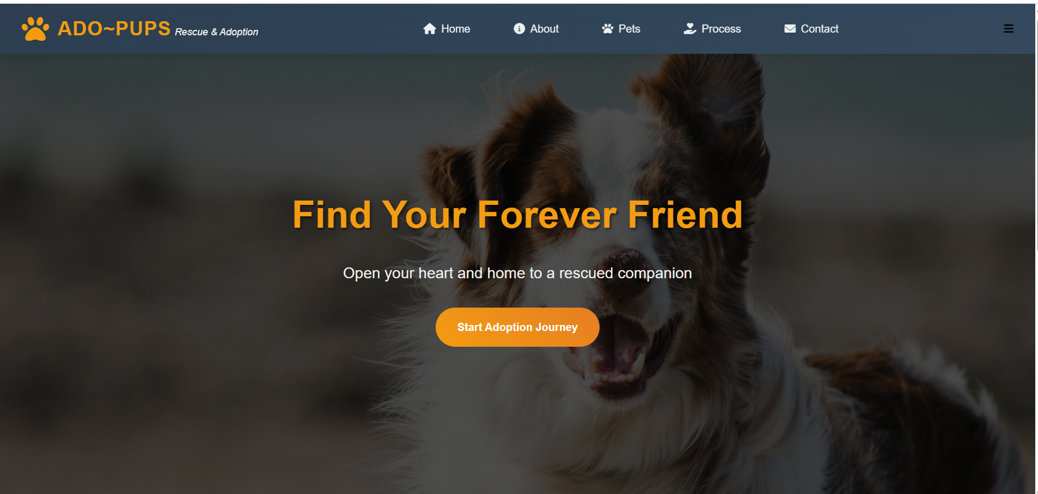
Figure 3.8 UI Home page of Dog Adoption System
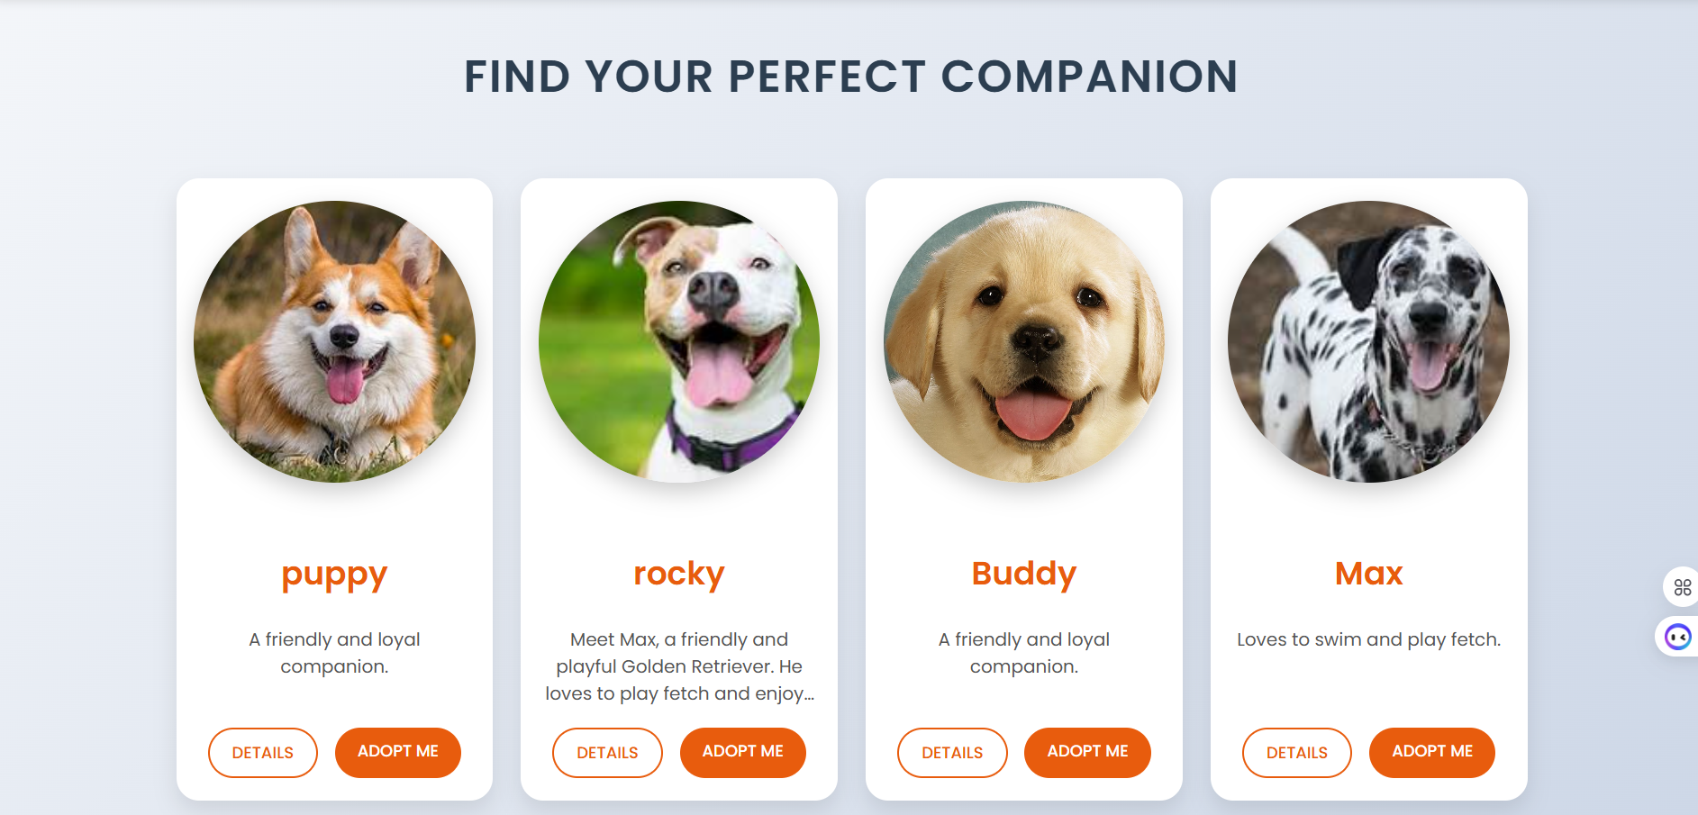
Figure 3.9 Animal page for Dog Adoption System
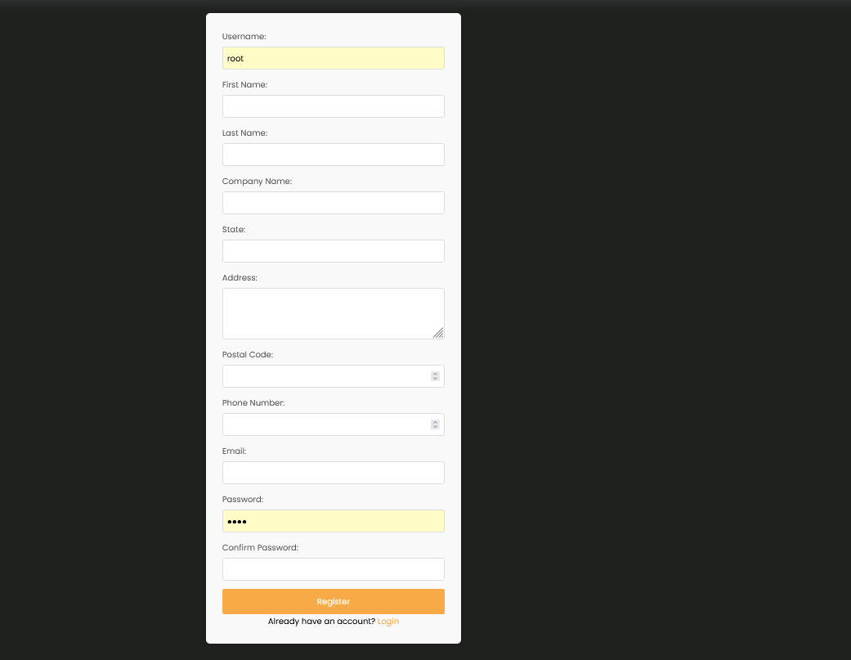
Figure 3.10 Signup page for Dog Adoption System
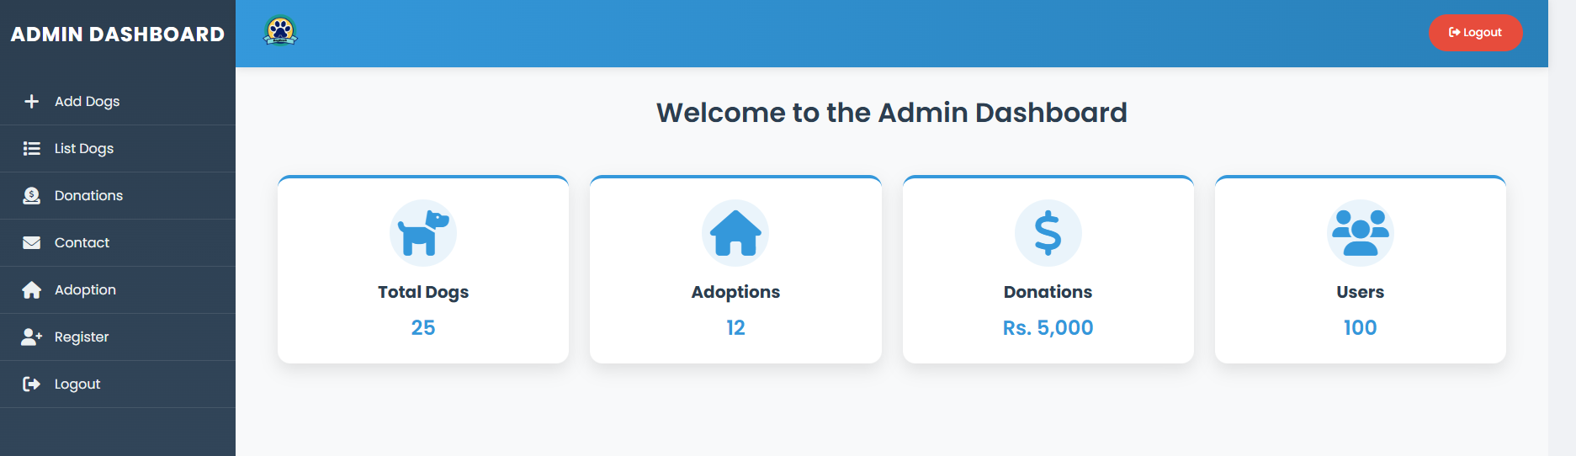
Figure 3.11 Dashboard for Dog Adoption System

CHAPTER 4: IMPLEMENTATION AND TESTING

4.1 Implementation

4.1.1 Tools Used (CASE tools, Programming language, Database platforms)
The following are the tools and framework used for the accomplishment of this project:
Frontend Tools
- HTML
In the Dog Adoption System, HTML is utilized to create and structure various webpages and components. It defines sections, headings, links, paragraphs, and other elements essential for the layout and content of the system. HTML is instrumental in organizing headers, paragraphs, images, and links for an efficient and user-friendly interface.
- CSS
CSS is employed to style the HTML elements in the Dog Adoption System. It designs various components using classes and IDs while employing inline, internal, and external stylesheets for customization. With CSS, we control text color, font styles, spacing between elements, column sizes, and overall layout designs, ensuring the system is visually appealing and well-structured.
- JavaScript
JavaScript is used to enhance the Dog Adoption System's interactivity, responsiveness, and dynamic behavior. It facilitates client-side validations and enables interactive features such as animations, dynamic content updates, and special effects on the webpage.
Backend Tools
- PHP
PHP serves as the backend scripting language for the Dog Adoption System, enabling the creation of dynamic webpages and server-side functionalities. It connects the system to the database, handles user authentication, encrypts data, and manages tasks such as adding, updating, and deleting records. PHP ensures secure and seamless interaction between the frontend and database.
Server
- Apache Server
Apache Server is used to execute PHP files and deliver fast, dynamic webpages in the Dog Adoption System. It acts as the foundation for running the backend scripts and handling requests efficiently.
Database
- MYSQL
MySQL stores all the necessary data for the Dog Adoption System. It performs CRUD operations—Create, Read, Update, and Delete—based on user requests, ensuring the database is well-managed and accessible.
Version Control System
In the Dog Adoption System, Git and GitHub are used to manage and track changes in the codebase effectively. Git acts as the version control tool, allowing developers to create branches, merge changes, and maintain a history of updates. GitHub serves as a remote repository, providing a centralized platform for collaboration, issue tracking, and code reviews. Together, they ensure smooth project workflows, secure backups, and easy access to the project from anywhere.
Documentation Tools
- MS Office
MS Office is employed to draft, edit, and format the documentation for the Dog Adoption System ensuring clarity and professionalism.
- Draw.io
Draw.io is utilized to create system analysis and design diagrams for the Dog Adoption System. Its drag-and-drop functionality simplifies the creation of visually clear and time-efficient diagrams to represent system components and workflows.

4.1.2 Implementation Details of Modules (Description of procedures/functions)
This section provides detailed descriptions of the major modules and their functionalities that have been implemented in the Dog Adoption System. The system is developed using HTML, CSS, JavaScript, PHP, and MySQL, focusing on both user (adopter/donor) and admin functionalities.

- User Registration and Login Module
This module allows new users to create an account and existing users to log in securely. It ensures that only registered users can access restricted functionalities like submitting adoption forms or donations.
Main Functions:
- registerUser():
  - Captures user's name, email, password, and other details.
  - Validates input data (e.g., valid email format, strong password).
  - Hashes passwords using password_hash () function in PHP for security.
  - Stores user information in the users table in MySQL database.
- loginUser():
- Authenticates user credentials.
- Uses password_verify() to compare entered password with hashed password stored in the database.
- Redirects to user dashboard on successful login.

- Dog Listing and Management Module (Admin Side)
Admins can add, update, or delete dog profiles that are available for adoption.
Main Functions:
- addDog():
- Captures dog's name, age, breed, health status, and image.
- Validates fields before uploading.
- Inserts data into dogs table along with the image path.

- updateDog():
- Allows admin to update existing dog profile.
- Updates record in dogs table.
- deleteDog():
- Deletes a dog profile from the system when adopted or no longer available.

- Adoption Request Module (User Side)
This module lets users apply for dog adoption through an adoption form.
Main Functions:
- submitAdoptionRequest():
- Users fill in adoption form including dog ID, personal information, and reason for adoption.
- Validates fields (mandatory fields check).
- Saves request in adoption_requests table.
- Shows a notification to user: "Your adoption request has been submitted and is under review."
- checkAdoptionStatus():
- Allows users to check status: Pending, Approved, Rejected.

- Adoption Request Review Module (Admin Side)
Admins review and manage user adoption requests.
Main Functions:
- viewAdoptionRequests():
- Lists all submitted adoption requests.
- Shows status, user details, and dog profile.
- approveRequest():
- Changes status of request to "Approved".
- Sends automated notification/email to user.

- rejectRequest():
- Marks request as "Rejected".
- Sends rejection notification to user.

- Donation Management Module
Users can donate money to support shelters, and admins can track all donations.
Main Functions (User Side):
- submitDonation():
- Captures donor's name, amount, email, and message (optional).
- Validates donation amount (should be positive).
- Stores record in donations table.
- Shows "Thank you for your donation" message.
Main Functions (Admin Side):
- viewDonations():
- Admin sees list of all donations, including donor names and amounts.

- User and Admin Authentication with Role Management
This module manages user and admin login and role-based access control (RBAC).
Main Functions:
- checkLoginRole():
  - Determines whether logged-in user is an admin or adopter based on database role field.
  - Redirects to appropriate dashboard.
- sessionControl():
  - Manages session variables to keep users logged in securely.

- Notification Module
The system automatically sends notifications for: Adoption request submission,Admin approval or rejection and Donation acknowledgment.
Main Functions:
- sendNotification():
  - PHP function to send in-app or email notification when triggered.
  - Templates used for different types of notifications.
- viewNotifications():
  - Displays recent notifications on user/admin dashboard.

- Admin Dashboard Module
This module is the central management area for administrators to control the entire system.
Main Functionalities:
Manage Dogs: Add, edit, delete dog profiles.
Manage Adoptions: View, approve, reject adoption requests.
Manage Donations: View donation history.
Manage Users: See registered user information.

4.2 Testing
System testing is performed by providing various training and testing datasets. This test evaluates the system's ability to provide accurate summary. Our system undergoes continuous testing during development. A sequence of testing conducted are as follows:

4.2.1 Test Cases for Unit Testing
Unit testing refers to the testing of every small modular component of the system, keeping them isolated from other modules. In this test phase, the errors were corrected and modifications made as and where required. Steps followed in performing unit tests:
- Conduct the code execution tests
- Identify and resolve any errors
- Determine that the test is complete

UNIT TEST CASES:
Project Name: Dog Adoption System
Priority: High
Description: Unit testing of individual functionalities in Dog Adoption System.
Test Objective: To validate each functionality/module works as expected.
Test Case Author: [Your Name]
Test Case Reviewer: [Reviewer Name]
Version: 1.0
Test Execution Date: [Insert Date]

Unit Test Case: Login Required Before Adoption Form Access (Valid)
Test Case ID | TC-U001
Objective | To ensure users cannot access the adoption form without logging in.
Test Steps | Login Required Before Adoption Form Access (Valid)
Input Data | 1. Navigate to adoption form without login.  2. System redirects to login page.
Expected Results | N/A
Actual Results | System prevents access and redirects to login page.
Test Environment | Windows 10, XAMPP, Chrome Browser
Execution Status | Pass

Unit Test Case: Login Required Before Adoption Form Access (Invalid)
Test Case ID | TC-U002
Objective | To verify the system denies form submission for unauthorized users.
Test Steps | Login Required Before Adoption Form Access (Invalid)
Input Data | 1. Try submitting adoption form without login.
Expected Results | N/A
Actual Results | Access denied, redirected to login.
Test Environment | Windows 10, XAMPP, Chrome Browser
Execution Status | Pass

Unit Test Case: Adoption Form Submission (Valid)
Test Case ID | TC-U003
Objective | To verify that a logged-in user can successfully submit an adoption form.
Test Steps | Adoption Form Submission (Valid)
Input Data | 1. Login to system.  2. Fill and submit adoption form.
Expected Results | Dog ID: 5, Name: Ram, Address: Kathmandu, Contact: 9876543210
Actual Results | Request sent for admin review.
Test Environment | Windows 10, XAMPP, Chrome Browser
Execution Status | Pass

Unit Test Case: Adoption Form Submission (Invalid)
Test Case ID | TC-U004
Objective | To confirm the system validates missing fields in the adoption form.
Test Steps | Adoption Form Submission (Invalid)
Input Data | 1. Login to system.  2. Submit form with missing fields.
Expected Results | Dog ID: None, Name: None
Actual Results | Show validation error: 'Fields Required'.
Test Environment | Windows 10, XAMPP, Chrome Browser
Execution Status | Pass

Unit Test Case: Donation Form Submission (Valid)
Test Case ID | TC-U005
Objective | To ensure successful donation submission with valid details.
Test Steps | Donation Form Submission (Valid)
Input Data | 1. Navigate to donation page.  2. Fill details.  3. Submit donation.
Expected Results | Name: Sita, Amount: $100, Email: sita@gmail.com
Actual Results | Donation recorded, thank-you message shown.
Test Environment | Windows 10, XAMPP, Chrome Browser
Execution Status | Pass

Unit Test Case: Donation Form Submission (Invalid)
Test Case ID | TC-U006
Objective | To validate error handling for invalid donation amounts.
Test Steps | Donation Form Submission (Invalid)
Input Data | 1. Submit donation with invalid amount.
Expected Results | Amount: -100
Actual Results | Show error: 'Invalid donation amount'.
Test Environment | Windows 10, XAMPP, Chrome Browser
Execution Status | Pass

4.2.2 Test Cases for System Testing
System testing focuses on validating the complete system’s functionality by verifying how different modules interact with each other in the entire workflow. It ensures that the system operates as expected under real-world conditions and meets the specified requirements. In the Dog Adoption System, system test cases cover the end-to-end processes such as user registration, adoption request submission, donation processing, and admin management. Each test case evaluates whether the system successfully integrates all components, handles user inputs correctly, and produces the expected outputs, ensuring smooth operation when deployed in a production environment.

SYSTEM TEST CASES:
Project Name: Dog Adoption System
Priority: High
Description: System testing of complete Dog Adoption System.
Test Objective: To validate the integrated functionality and workflow of the system.
Test Case Author: [Your Name]
Test Case Reviewer: [Reviewer Name]
Version: 1.0
Test Execution Date: [Insert Date]

System Test Case: Complete Adoption Workflow (Valid)
Test Case ID | TC-S001
Objective | To verify that the complete adoption workflow functions correctly from user request to admin approval.
Test Steps | Complete Adoption Workflow (Valid)
Input Data | 1. User logs in.  2. Submits adoption form.  3. Admin reviews and approves.  4. User notified.
Expected Results | User ID: 1, Dog ID: 5
Actual Results | Request approved, user notified.
Test Environment | Windows 10, XAMPP, Chrome Browser
Execution Status | Pass

System Test Case: Complete Adoption Workflow (Invalid)
Test Case ID | TC-S002
Objective | To ensure the system handles invalid adoption requests correctly.
Test Steps | Complete Adoption Workflow (Invalid)
Input Data | 1. User submits adoption request with non-existing dog ID.
Expected Results | User ID: 1, Dog ID: 9999
Actual Results | Show error: 'Dog not found'.
Test Environment | Windows 10, XAMPP, Chrome Browser
Execution Status | Pass

System Test Case: Donation Process and Admin Review (Valid)
Test Case ID | TC-S003
Objective | To validate that donations are recorded and visible to admins.
Test Steps | Donation Process and Admin Review (Valid)
Input Data | 1. User submits donation.  2. Admin views donation.
Expected Results | Name: Sita, Amount: $100, Email: sita@gmail.com
Actual Results | Donation listed in admin dashboard.
Test Environment | Windows 10, XAMPP, Chrome Browser
Execution Status | Pass

CHAPTER 5: CONCLUSION AND FUTURE RECOMMENDATIONS

5.1 Lesson Learnt / Outcome
This project provided valuable learning experiences across several domains. It supported the development of problem-solving skills, including teamwork, independent problem-solving, effective utilization of guidelines, and enhanced communication and writing proficiency. Furthermore, the project contributed to the development of team management skills.
- Teamwork
This team project emphasized the importance of collaboration in system development. Team members gained practical experience in collaborative work, efficient task delegation, and collective problem-solving to address challenges encountered during the development process.
- Problem-Solving Skills
This project enhanced the team's ability to identify and resolve technical issues. Each challenge encountered provided a valuable learning opportunity, fostering expertise in troubleshooting system failures, debugging code, and developing creative solutions to unforeseen problems. This practical experience strengthened critical thinking and problem-solving skills.
- Time Management
The most important lesson learnt was management of time according to the
complexity of the system components i.e. knows which components to prioritize.
- Documentation Skills
This project provided valuable experience in creating thorough and comprehensible project documentation. The team developed skills in writing project proposals, designing system diagrams (including database structures and use cases), and producing user manuals. This process highlighted the critical role of effective documentation in project success and long-term maintainability.

5.2 Conclusion
In summary, the Dog Adoption System provided a user-friendly solution to make dog adoption easier. It reduced the gap between adopters and shelters, improved communication, and helped more dogs find loving homes. By using digital tools, the system made the process efficient and supported responsible pet adoption.

5.3 Future Recommendations
- Mobile App: Develop a mobile app to make browsing and requesting adoptions easier anytime, anywhere.
- Real-Time Chat: Add a chat feature so adopters and shelters can communicate directly.
- Guest Access: Allow visitors to view dog profiles without needing to create an account.
- Data Backup: Add backup options to keep dog profiles and user data safe.
- Better Search & Filters: Improve search options to help users find dogs faster based on breed, age, or size.
- Admin Tools: Provide better tools for admins to manage dog profiles, user accounts, and adoption requests.

References

[1] | K.S.Davis, Journal of Animal Welfare Technology, vol. 45, no. 3, pp. 112-124, 2020.

